ASSIGNMENT – 3

SMART FASHION RECOMMENDER APPLICATION

|  |  |
| --- | --- |
| Assignment Date | 20.10.2022 |
| Student Name | ARTHI.S |
| Student Roll No | 820319104046 |
| Max Mark |  |

**Questions:**

# Create a Bucket in IBM object storage.

1. Upload 5 images to IBM object storage and make it public. Write html code to displaying all the 5 images.
2. Upload a CSS page to the object storage and use the same page in your HTML code. 4.Design a chatbot using IBM Watson assistant for hospital. Ex: User comes with query to

know the branches for that hospital in your city. Submit the web URL of that chat bot as a assignment.

5.Create Watson assistant service with 10 steps and use 3 conditions in it. Load that script in HTML page.

Create a Bucket in IBM object storage.

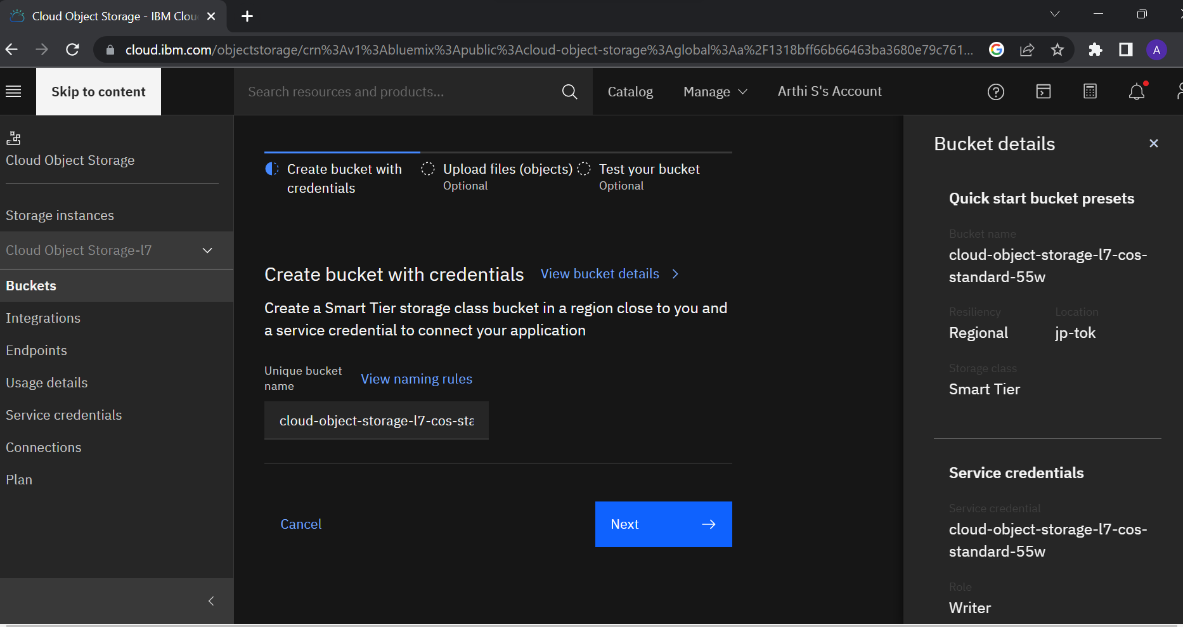

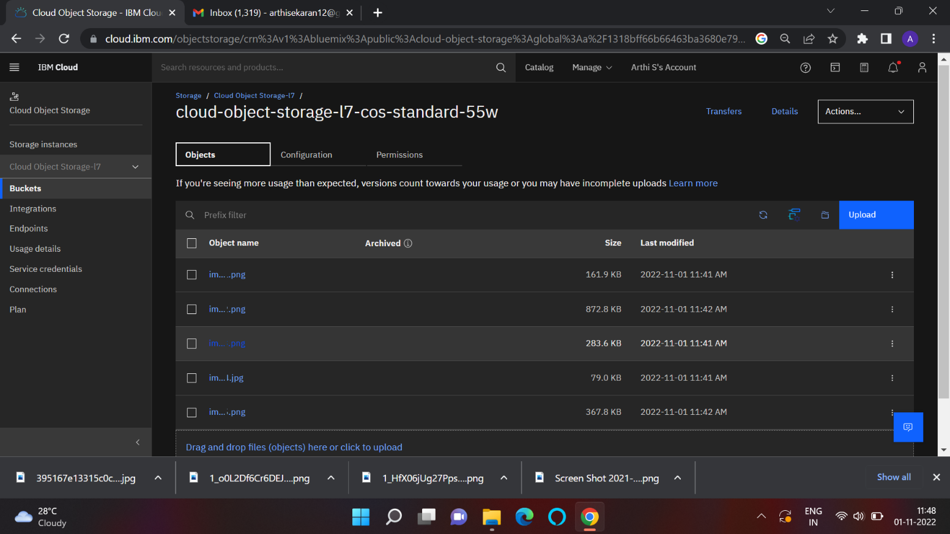

**Make the images to public access**

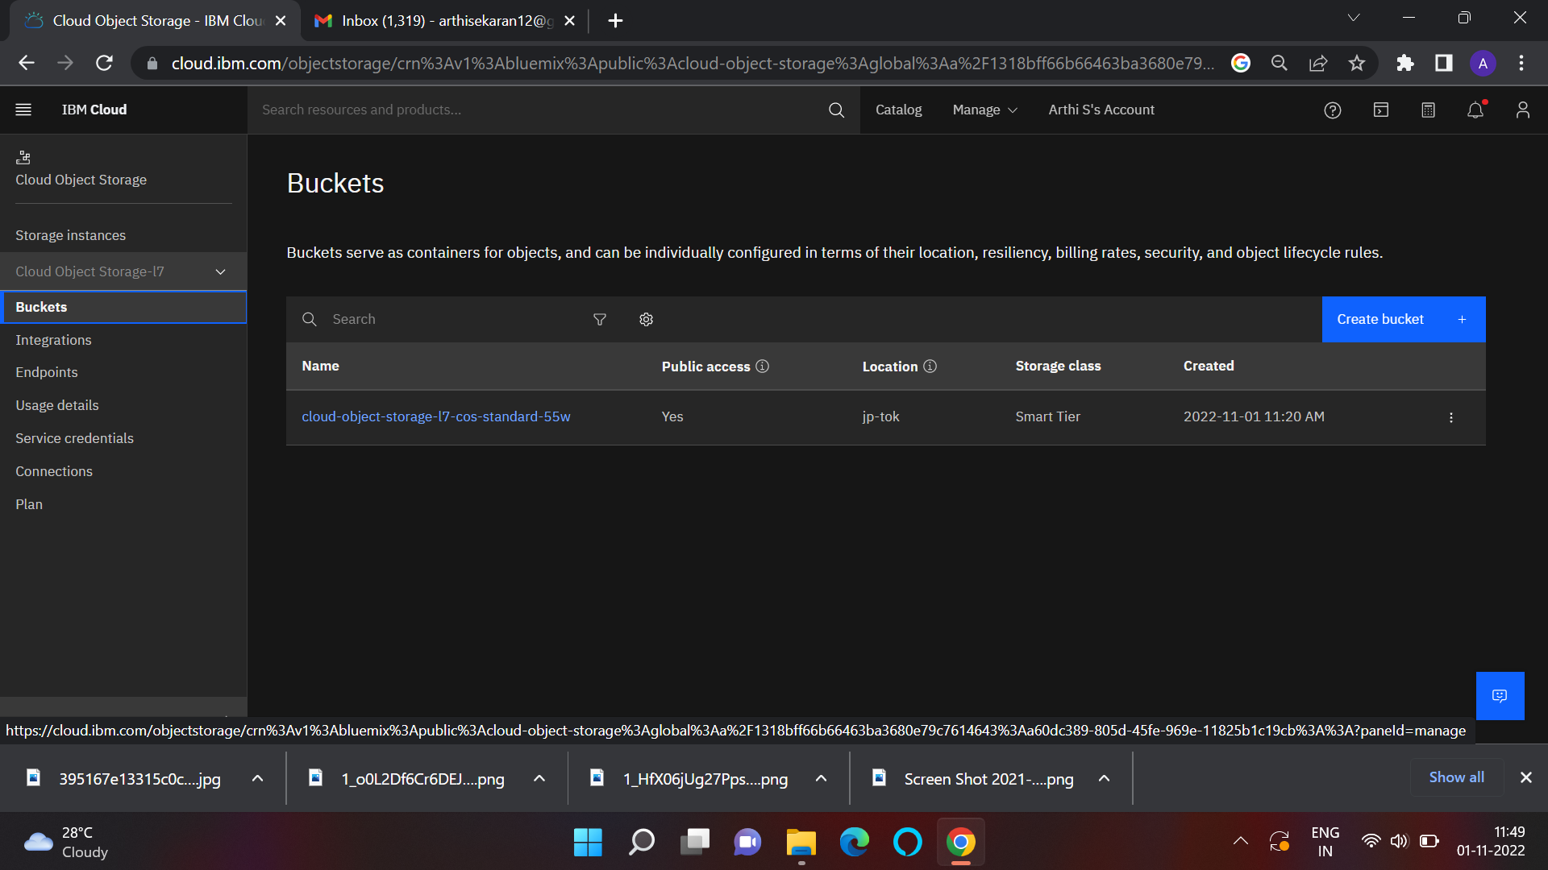

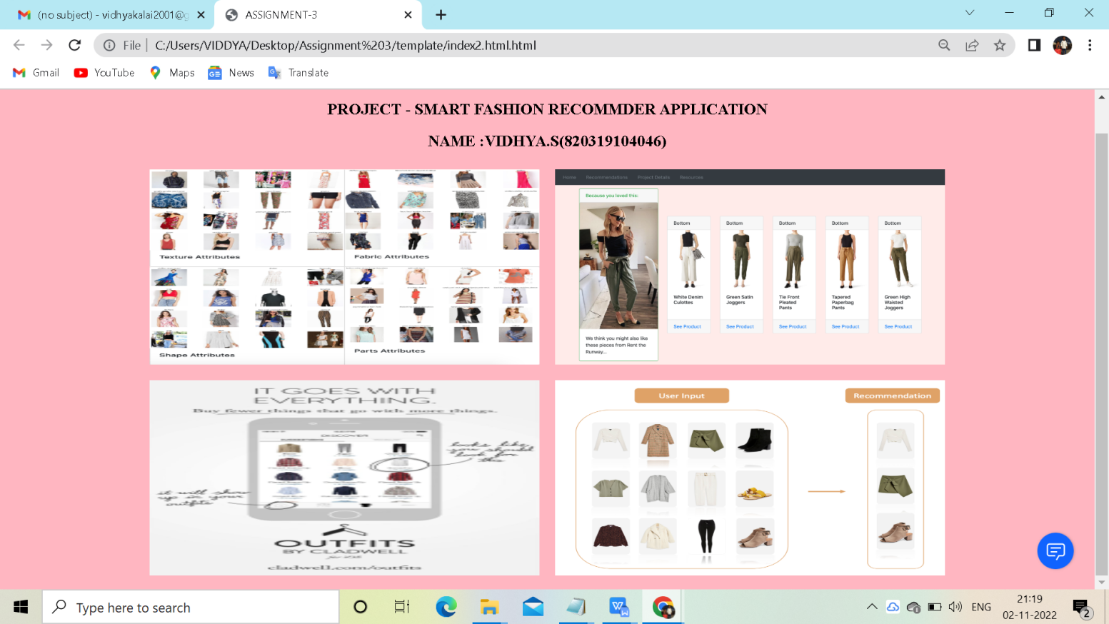

Create a Chatbot :

CHATBOT URL :

https://web- chat.global.assistant.watson.appdomain.cloud/preview.html?backgroundImageURL=https%3A%2 F%2Fjp-tok.assistant.watson.cloud.ibm.com%2Fpublic%2Fimages%2Fupx-c371dcde-b75b-4b8f- aa33-abd1b615fa7d%3A%3A3c928eb7-b86b-4987-8011-28bd0b23488b&integrationID=238a365b- 6981-4baf-b761-3555f7f9f4c9&region=jp-tok&serviceInstanceID=c371dcde-b75b-4b8f-aa33- abd1b615fa7d

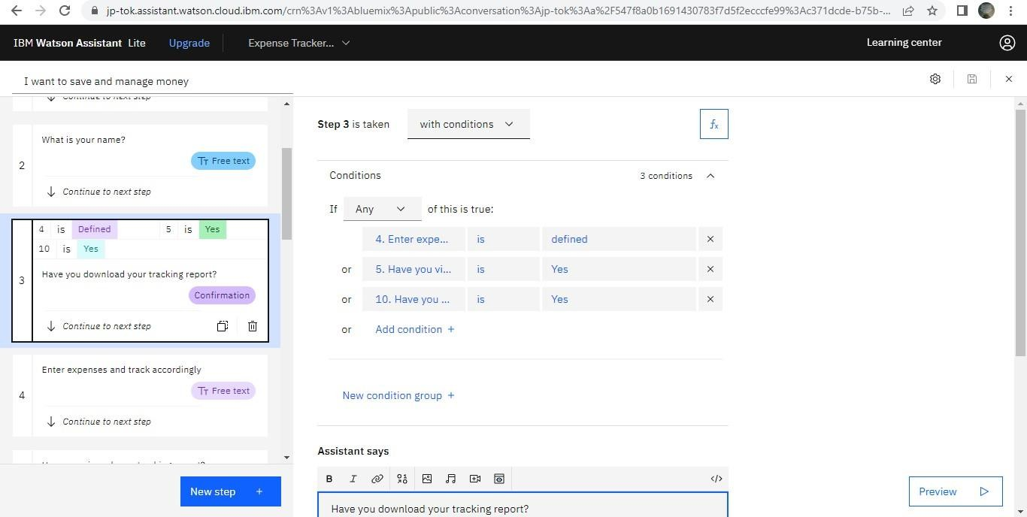

Load that script in HTML page.

